Nagoyakko Support Information Relay Sheet
The information on this sheet concerning your child’s circumstances and assistance methods will be conveyed to their school in order to make their everyday school life more comfortable.
The important and private personal information on this sheet will always be handled with the utmost care, and will never be used for other purposes.

Date of Completion (YYYY/MM/DD) |  | Completed by (Full Name)

☆ Child Profile
School Name |  | Class Name
Full Name (Last, First) |  | Sex |  | Date of Birth
Address | Postal Code ―  TEL （ ） ― |  | Date of School Admission
Contact Information | Home or Workplace TEL (Easy to reach Home or Mobile Phone)

Attributes requiring special or individual attention | (Diagnosis name if available: )
Objective before Graduation
Role of Staff and Specific Assistance Methods
Nursery School / Kindergarten
Family
Medical Care
Public Welfare

- Please write what is important to tell the school (Concerns and expectations from guardians and the school.)
☆ Specific details and methods of assistance
Name of Homeroom Teacher
Child’s Circumstances |  | Planned Solution
Daily Lifestyle
(Eating, excretion, changing clothes, etc.)

Human Relations
(Relationship with friends and guardians)
Language
(Comprehension, expression)
Play Activities
(Likes and difficult activities)

Group Behavior

☆ Other necessary considerations
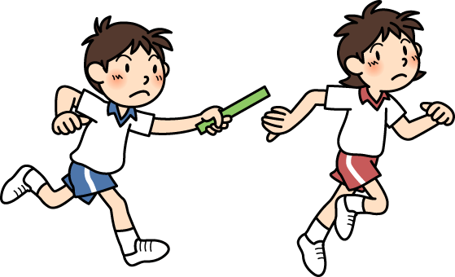
* I permit the information on this sheet to be
submitted to my child’s school for use.

Name of Guardian

